# **APM-3199 - OWASP ZAP PiaB integration and report generation**

### **Configuration of OWASP ZAP**

* Install ZAP in your AWS instance.

<https://www.owasp.org/index.php/OWASP_Zed_Attack_Proxy_Project> and

Download ZAP 2.7.0

* Select “**File**” menu and select “**Session Properties**”. It opens session Properties Panel

Go to Select -> **“contexts”** menu and click in -> ” **Authentication**” and give details as shown in right panel

1. Go to -> right Panel -> ” **Authentication method for the context**”

Select in “**Form-based Authentication**” Options

1. After that go to “**Configure Authentication method**”

->Login Form Target URL

Please give the application URL. For Ex: “ui-proxy-1-0-test.magellancloud.com/portal”

* Login Request Post Data (if any)

Please give application Username and Password as well in below Format

-> “Username=yourusername&Password=your password”

3. Go to -> click “ok” button.

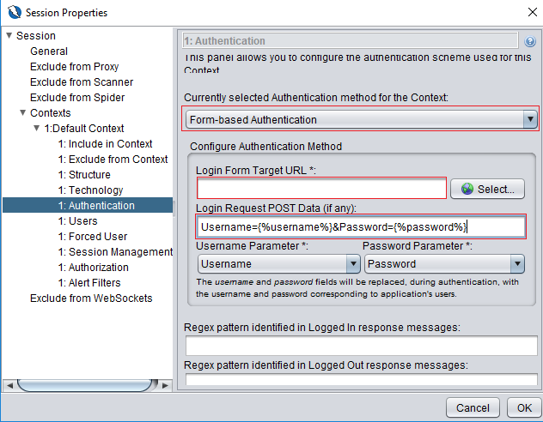

* Go to ZAP **“Quick Start”** select tab Session ->”URL to Attack”-> give application URL and

Click the **“Attack”** Button. It scans the entire application.

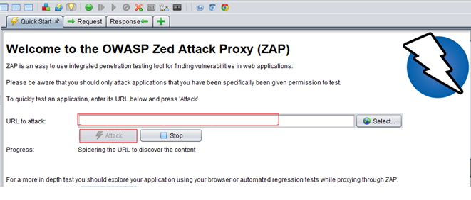

* After Scanning is completed by 100% in scan Spider and Active Scan Check in “alerts” tab for details of the application information. We can also get Risk Level Details in summary of alerts- informational, Low, Medium and high.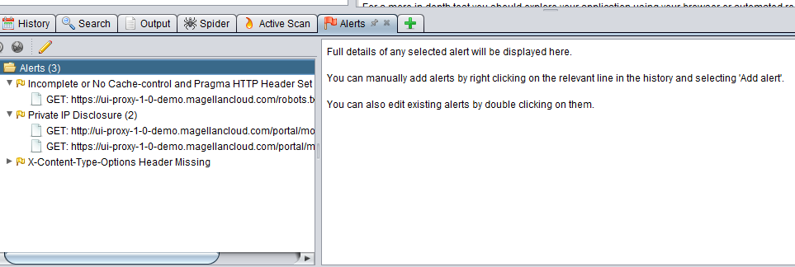
* To get full detailed report go to “Report” Menu click ->Generate HTML/XML/JSON Report”

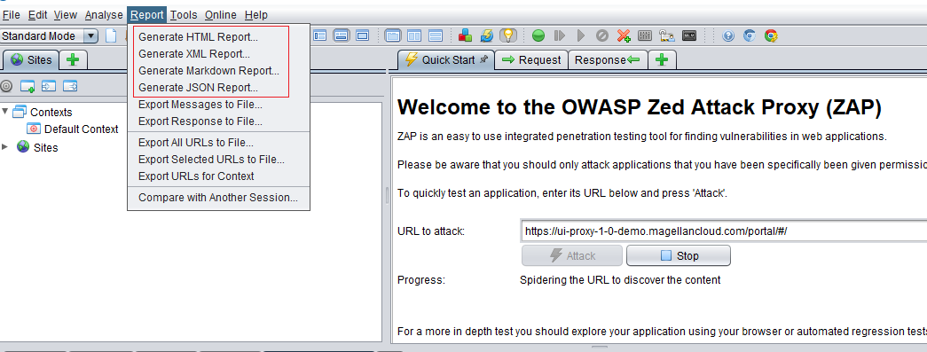

* Report Summary Info in application appears shown:

1. HTML format Report:

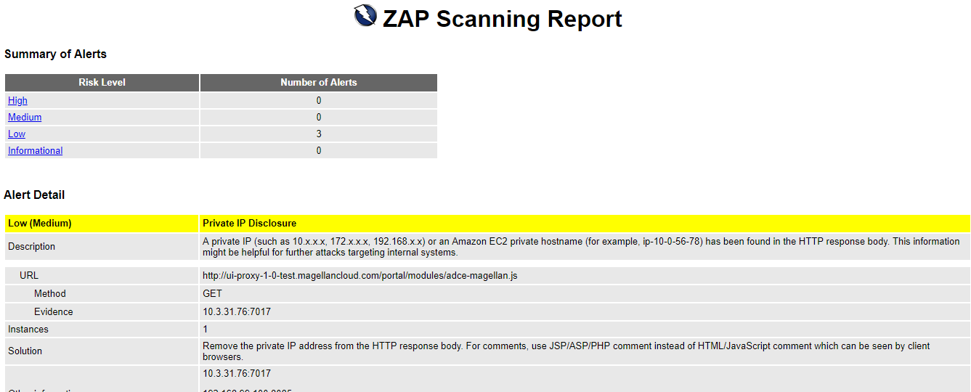

1. Json Format

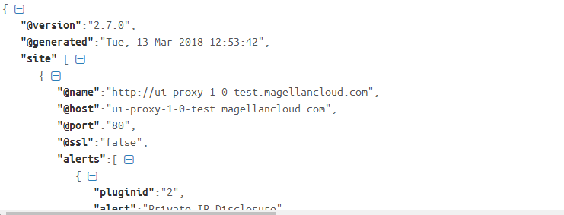

1. XML Format:

